**[Banuwa](http://www.bethsnotesplus.com/2013/06/banuwa.html)**

[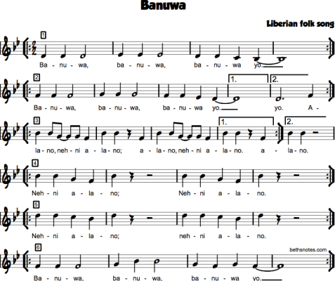](http://www.bethsnotesplus.com/2013/06/banuwa.html)